Professional Development File Import

In lieu of updating each teacher via the Professional Development page, a new upload option has been added. In order to successfully import professional development hours, the following steps must be completed correctly. All current records in LEA Profile will be replaced by the records in your uploaded file.
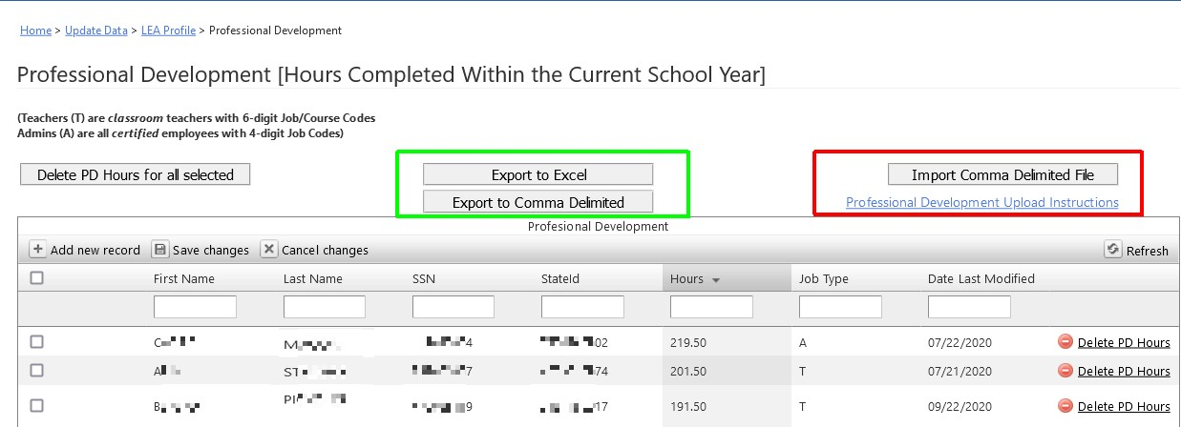
- A new button has been added to the Professional Development screen, “Import Comma Delimited File”. There is also a link to instructions for its use.
- You may want to export your data via the “Export to Comma Delimited” button above.
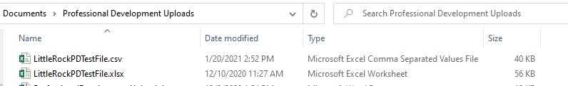
- The import file will be a comma delimited file. You may create this file in Microsoft Excel (or other spread sheet), but save it as a .CSV file format.

- For professional development, your file will have 4 columns:
  - District LEA
  - SSN of employee (you may omit leading zeros)
  - Number of professional development hours being recorded
  - Whether the employee is a Teacher, or Administrator DO NOT USE COLUMN HEADERS. This will result in an error.
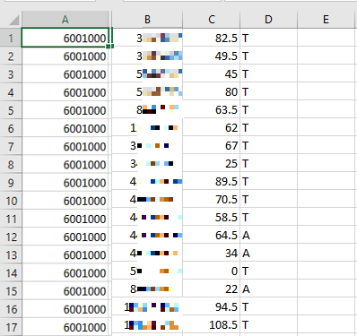

- Clicking on the Import button will take you to the first page of the import process:
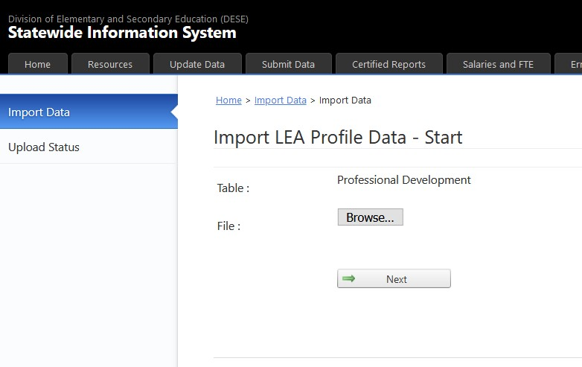
- You will need to click on the browse button to navigate to where you have saved your comma delimited Professional Development Hours file.
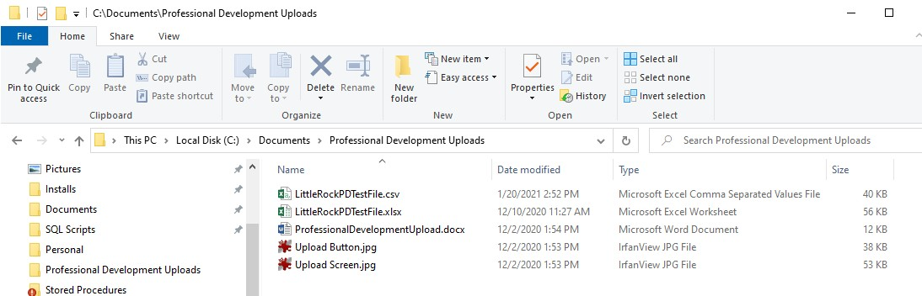

- Clicking “Next” will upload and attempt to validate the input file.
- If you have an error on your upload, you may get the following upload errors:
  - Wrong number of columns produces this error:
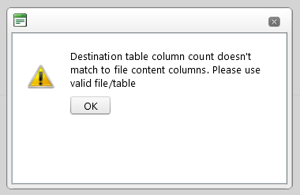

  - Extra blank lines at the bottom of the input file will produce the following error:
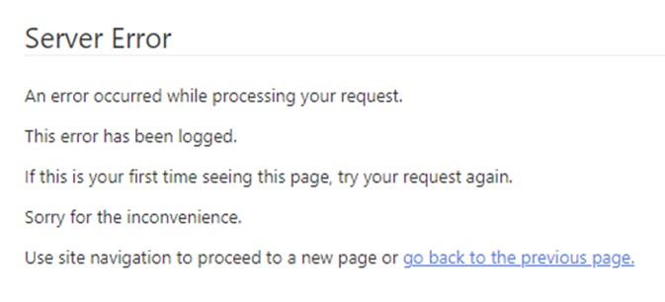
- If your upload is successful, then the file will be inspected for errors of content.
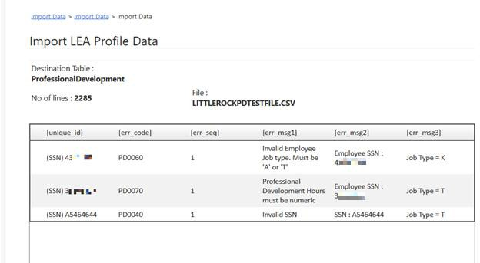
- If errors are displayed, you will need to correct your comma delimited file, and re-upload.
- An error free file will result in the following pop-up:
- Click OK

- Click the “Import” button in the lower right corner of the page:
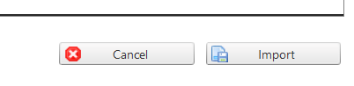
- One final warning that this is permanent and will replace all current records.
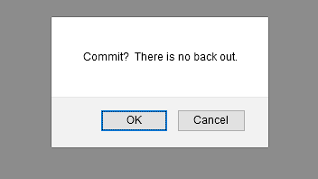
- Once committed you will be returned to the Professional Development page where your imports have been further checked by the system.

